*Cost of Living****Where is the COL most affordable?***

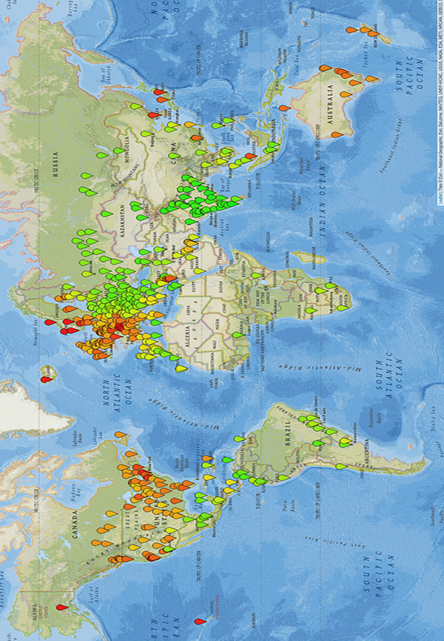

**IST 707: march 2020, sunday 4pm class**

**Project Team:**

Anant gupta

Carlos de los Angeles

Todd tetreault

**Introduction**

We live in world that is no longer separated by geographic boundaries. More than ever our cultures and populations have mixed in rapid fashion. The surge of study aboard programs, international work assignments and cultural immersions have sparked more interest in those seeking to relocate and experience different places to live. According to a survey by Deloitte, Gen X, Gen, and Gen Z prefer to travel more and change jobs more often, versus spend their lives in the same place or company. While everyone has a list of places in mind they would like to live, and an abundance of data available on-line for research, there needs to be a better way to analyze those places based on personal lifestyle via cost of living.

The web, while plentiful with data, can often be difficult to find what is most relevant to your situation. Any search on “top places to live” will help you understand, with ~ 3 million search results. Also, every source of COL data considers different variables for analysis. As such, our team set out to determine if we could use data analysis techniques to simplify the COL equation by identifying a select number of variables that would drive an efficient decision-making process.

The motivation, our business problem to solve, came from one of our team members. As a newly empty nester, working for a large multi-national corporation, he is contemplating his next move and relocation. He is in search for a city where with his earning potential would be considered medium to high and can lead to a comfortable life due to the low to medium cost of living (defined as surplus).

* **Analysis**
* **1] The Data**

The data set is from Kaggle ( <https://www.kaggle.com/stephenofarrell/cost-of-living>). The data is a comparison of the cost of living in various cities, as gathered by popular site numbeo. The dataset **(See Figure a)** contains cost of living data for 160 cities from 80 different countries. The data from these cities shows observations across 55 variables, such as: Meals, Clothing, Cost to borrow, Beer, Wine, Housing, etc. The cost for these items is given in Euros. On Deeper analysis we understood that the data belongs to mainly 5 categories – Food, Transportation, Clothing, Entertainment, and Living expense. In addition, there was one item, average monthly net income, that was contra to cost of living.

**Figure a: Kaggle COL data set (CSV file)**

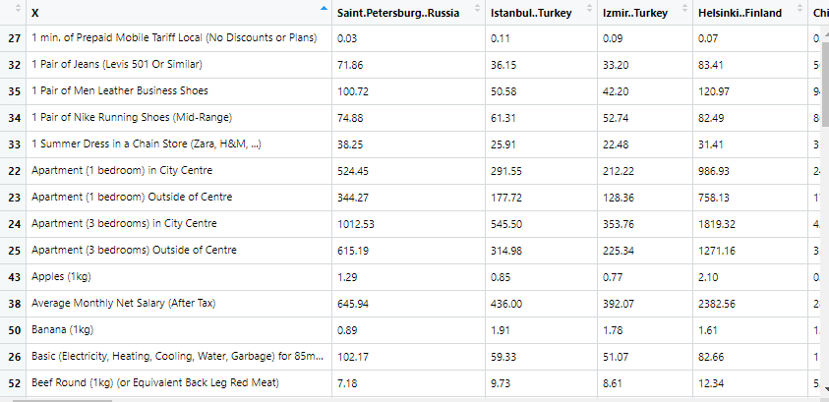

* **About the Data**
* Fundamentally there were few issues with the dataset, in that there we no duplicates or missing (N/A) observations. What we did find were some immediate limitations to the data, as follows: (1) the data was all numeric and did not have any categorical observations (e.g. like the Titanic data had “Survival”), (2) the observations had to be normalized as they contained very different units of measure (liter, gallon, one, month, trip, kg, etc.), (3) some of the data was not in fact cost data (e.g. average monthly net income and interest rate), and (4) no comparator data (e.g. how does that city compare to the average of the country, region, GDP, etc.)
* For ease of manipulation (tidy) we created an additional file called “Cost of Living Descriptions”, this allowed us to have an entirely numeric data set, which we could then analyze through basic statistics and allow for easier normalization. Secondly, we created a file that allowed for categorization of the data. This file created buckets (High, Medium and Low), we used standard deviation (> +1, <+1 or >-1, <-1) to classify observations into High, Medium and Low.
* **Cost of Living Description (See Figure b):** The description dataset was created with the same fields as that of the cost of living data but split into sensible variables. It had the following fields:

Description: This field contains the observations from the cost of living data for example – Meal, Inexpensive Restaurant, Meal for 2 People, Mid-range Restaurant, Three-course, McMeal at McDonalds (or Equivalent Combo Meal) etc.

Name: This field is the simplified form of description which is usable unlike the description field. Example – “Meal, Inexpensive Restaurant” became “inexpensive_restaurant” and “Cinema, International Release, 1 Seat” became “cinema” etc.

Quantity – Quantity is the quantity of a particular observation

Unit – The unit of that particular observation ex – liter, grams, each, meters squared etc.

Category - As stated earlier, the data was not categorized. Hence it was decided that the observations will be divided into categories such as Food, Transportation, Commodity, Living, Entertainment, Clothing, Income, Cost to Borrow and Other to make our data analysis such as clustering more precise.

**Figure b: Cost of Living Description**

* 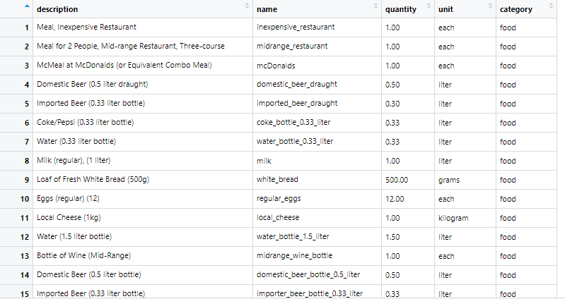

**High_medium_low_observation (see Figure c):**  This file allowed us to categorize our data to assess, more easily, High/Medium/Low observations, which better facilitated our association rule mining.

**Figure c: High, Medium, Low (csv) Observations**



**Data Analysis Method’s**

The first analysis we ran, using our data, was basic statistics (correlations analysis, ***see Figure D***) to get a sense of what variables where related and potentially were good variables to test in ARM and clustering techniques.

As suspected, due to many variables, analysis and visualization quickly became a challenge. Focus turned to basic statistical analysis. The strongest correlations are within like items (e.g. category). In addition, Average Monthly Net Income, Interest Rate and Cinema had the strongest correlations. While Income & Interest Rate had the largest impact on overall COL and became a focus as we moved to clustering. As shown in Figure d: Correlation Matrix, mortgage_interest_rate has a strong negative correlation with pretty much every other field in our data set.

**Figure d: Correlation Matrix**

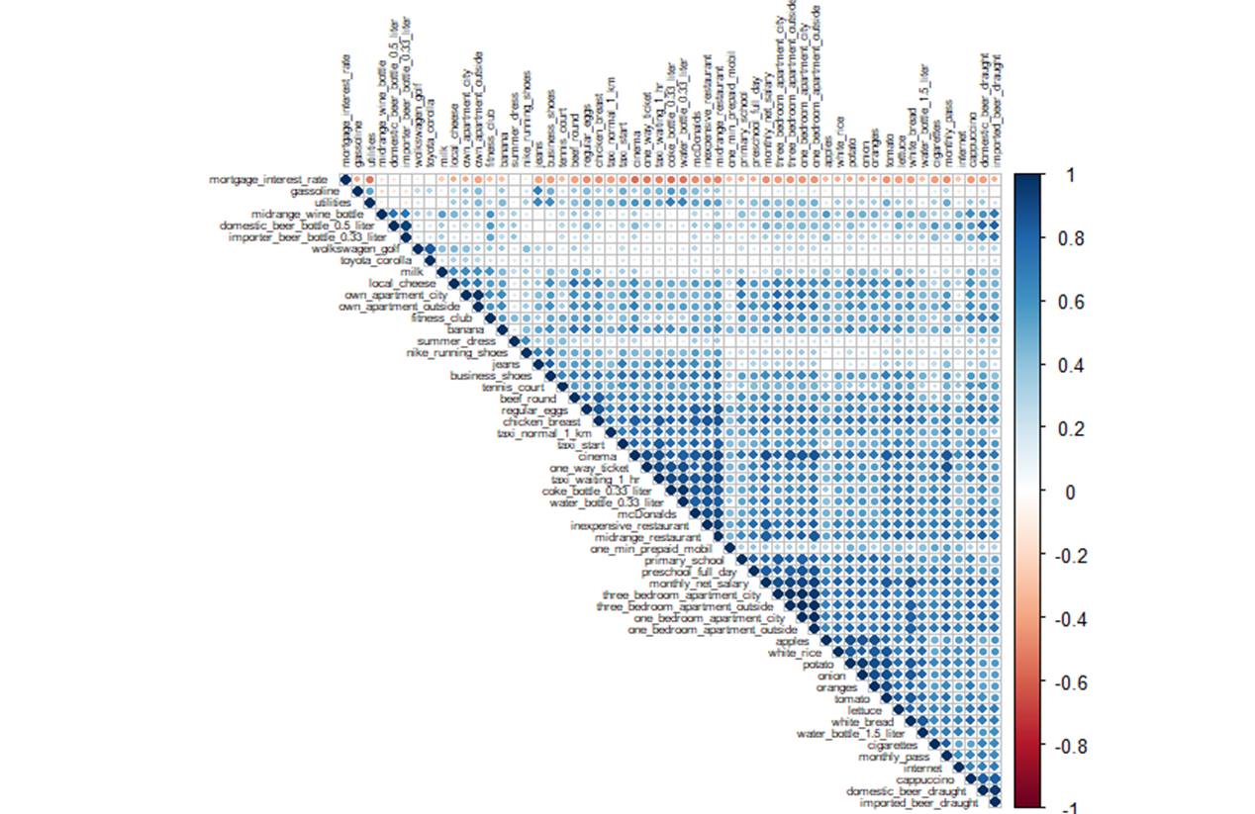

**Association Rule Mining –**

Our initial EDA revealed some correlations but given the number of observations we needed to categorize our data. Our data set lacked categorical or outcome data (i.e. like Loan or Titanic data), so we had to create categories for supervised learning. As such, we used standard deviation (> +1, <+1 or >-1, <-1) to classify observations into High, Medium and Low.

Association rules are simple If/Then statements that helps us discover relationships between seemingly independent relational databases or other data repositories. Association Rule Mining does not run on numerical data, instead it is most suitable for non-numeric categorical data. And hence it was pertinent to convert our continuous numerical data into categorical data ***as shown in Figure c.***

The main goal of association rule mining is to observe frequently occurring patterns, correlations, or associations among dataset. What we were trying to observe was patterns in the data, specifically did all high COL variables get associated, where things like income and interest rate highly correlated, etc.

Depending on the following two parameters the important relationships are observed –

1. **Support** – Support indicates how frequently the if/then relationship appears in the dataset
2. **Confidence** – Confidence is the indicator of the number of times these relationships have been found true.
3. **Lift** – is the ratio of the observed frequency of co-occurrence of items in the relationship and the expected frequency.

In applying ARM to our project, we set our RHS to mortgage interest rate (shown as most significant in correlation matrix) to see if monthly income would also emerge as a key variable.

**Applying ARM to the Project**

1] Support – 0.2, Confidence – 0.07

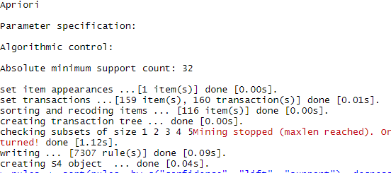

As can be seen the number of rules generated (7,307) was quite high. We focused on our RHS, as noted above and investigated our top 10 rules ***(See Figure e).*** We noted that, as was consistent with our correlation matrix , similar items appeared: income, apartment and transportation (gas/taxi). Even more telling, the rules appeared in the demarcation that was expected (when mortage_interest_rate is low then most of the LHS is going to be med or high). Note, some strange rules emerged as a result (e.g. Chicken)

**Figure e: Top 10 Rules (ARM)**

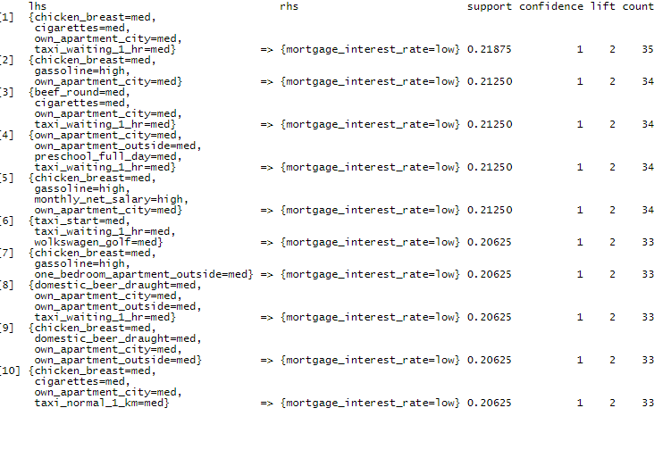

**Analysis / Modeling:**

As we believed interest rate to be one of the key indicators impacting overall cost of living, we wanted to better understand what other variables were affected by the interest rate. As the interest rate is a big consideration when shifting to a new place, we set that variable as the RHS. As you can see, ***in Figure e above,*** there is a relationship between different categories such as food, housing, education, transportation and mortgage rate.

**Distance Measures**

The classification of observations into groups requires some methods for computing the distance or the dissimilarity between each pair of observations. The choice of distance measures is a critical step in clustering. It defines how the similarity of two elements (x, y) is calculated and it will influence the shape of the clusters. The classical methods for distance measures are Euclidean and Manhattan distances, and by default most of the common clustering software’s use Euclidean Method. **We will be using the Euclidean distance method for K-Means clustering.**

Clustering is a broad set of techniques to find subgroups of observations within a data set. On Clustering observations, the expectation is that observations in the same group would be similar and observations in different groups to be dissimilar.

K-means clustering is the simplest and the most commonly used clustering method for splitting a dataset into a set of k-groups, and perfect for numeric data sets. In order to accurately cluster our data, we ranked our cities based on the total cost of living, Average Monthly Income and Interest Rate. This ranking allowed us to be more thoughtful in choosing our initial centroids (very important in k-means clustering). We did run this focusing only on Income / Interest Rate (as our x,y) and we saw the limitations (discussed in class) where it is very sensitive to outliers. For example, Buenos Aires has an interest rate of 48%, with the next nearest observation at 24%, which dramatically skewed the cluster.

**Applying K Means to the Project**

1. The first requirement for running the K means algorithm is to indicate the number of clusters (k) that will be generated in the final solution. By looking at the data it was decided that the data would be divided into 3 basic clusters (k=3):
   1. **Surplus Cities**– Income high, Cost to borrow is low, Income in excess of cost of living by 50%
   2. **Neutral Cities** - Income Medium/Low, Cost to Borrow Medium/High and Income is equivalent to cost of living
   3. **Deficit/Debt Cities** - Income Low, Cost to Borrow High and cost of living > Income by more than 50%
2. The second requirement for running the K means is the nstart variable. The nstart options attempts multiple configuration of clusters and reports the best one. In the program the **nstart is 100** and this will generate 100 initial configurations and reports the best of these.

**Output of the K Means**

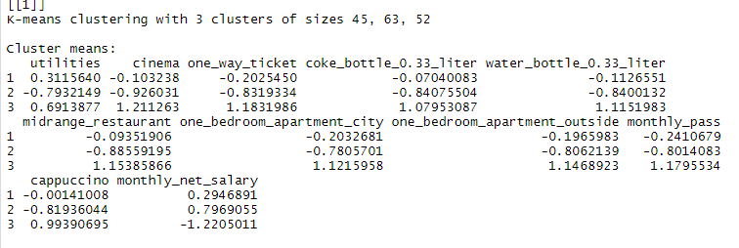

**As can be seen from the above image, there are 3 clusters formed. There are 45, 63 and 52 cities in respective clusters.**

**Cluster 3**

Cluster 3 has 52 cities in it and it is categorized as surplus. These cities have high income and usually low cost of borrowing ensuring that the income is in excess of cost of living by 50%. The list below, ***in Figure f below***, shows the first 30 cities of the 52 cities in the cluster surplus.

**Figure f: Cluster 3 (k means)**

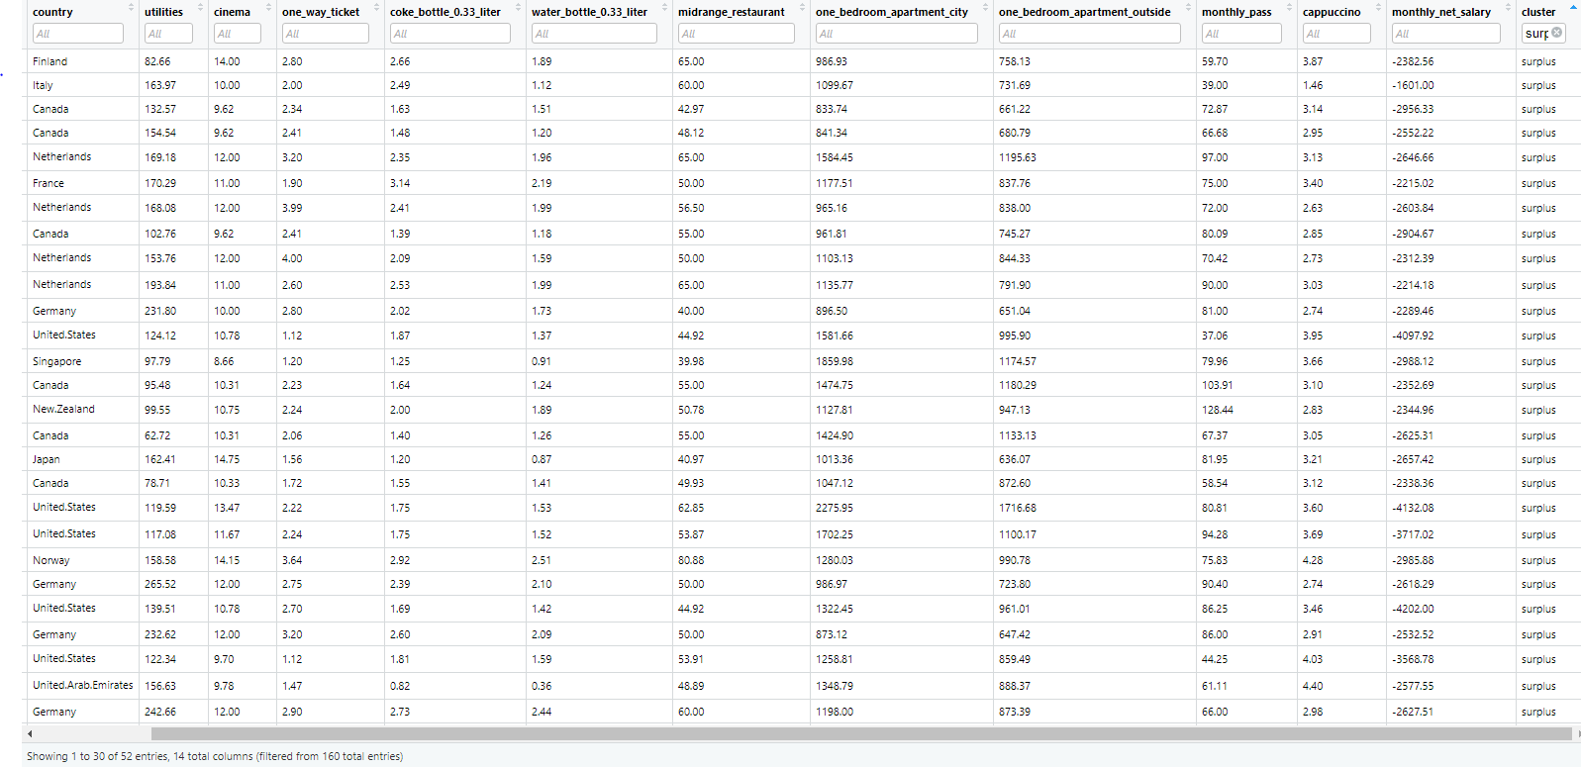

**Cluster 2**

Cluster 2 ***(Figure g)*** has 63 cities in it from different countries and is categorized as debt. These countries have low income while the cost to borrow is high. Typically, it was observed that the cost of living was in excess of the income by 50%.

**Figure g: Cluster 2 (k means)**

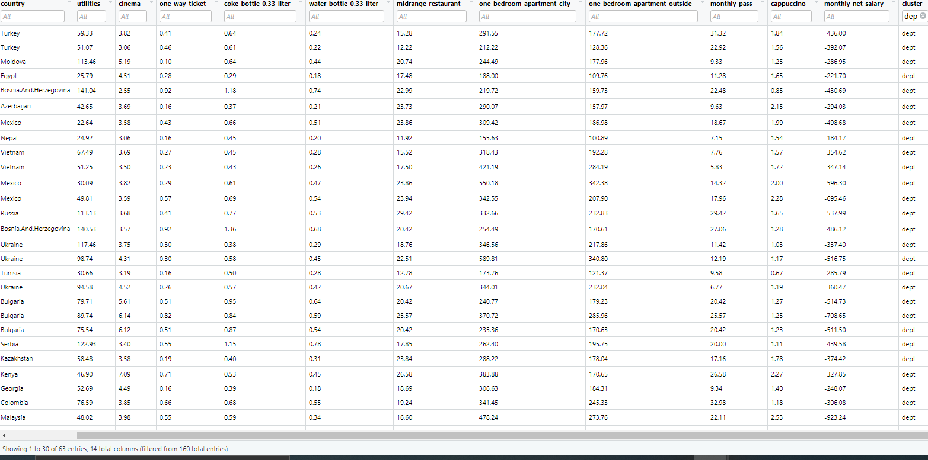

**Cluster 1**

Cluster 1 ***(Figure h)*** has 45 cities from different countries and have been categorized as neutral. These cities have medium income and the cost to borrow is on an average medium, cost of living is equivalent to the income.

**Figure h: Cluster 1 (k means)**

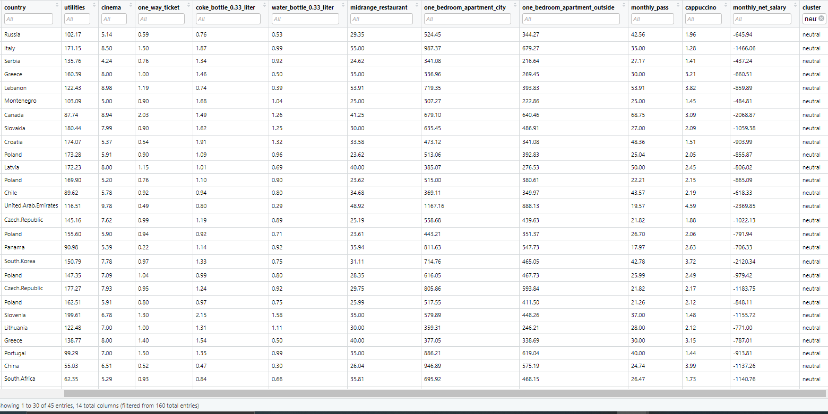

**Clustering Visualization using the fviz function**

**Figure i: K Means Cluster Visualization**



**Hierarchical Clustering Algorithm**

Hierarchical clustering is another approach to clustering just like the k-means clustering for identifying groups in the dataset. It is not required to pre-specify the number of clusters to be generated as is required by the k-means approach. Hierarchical clustering results in a tree-based representation of the observations, called a dendrogram.

**Output of HAC**

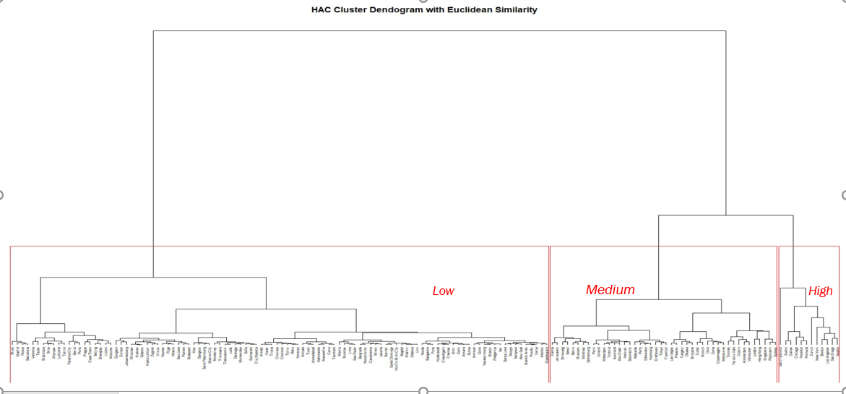

As can be observed in the diagram, the dendrogram has been divided into 3 clusters - Low, Medium and High. We felt that k-means gave us a much more intuitive result, as HAC had far too many results in the Low category. (Note: **Low** – the debt cities / **Medium** – Neutral Cities / **High** – Surplus Cities).

**Supervised Learning Algorithms**

Supervised learning is where we have the input variables (x) and an output variable (Y). Then we use an algorithm to learn the mapping function from the input to the output [Y = f(X)]. The goal is to approximate the mapping function so well that when there is new input data (x) then the algorithm can predict the output variables (Y) for that data.

It is called supervised learning because the process of an algorithm learning from the training dataset is somewhat like a teacher supervising the learning process. Since the correct answers are known, the algorithm iteratively makes predictions on the training data and is corrected. Learning stops when the algorithm delivers an acceptable level of performance.

**Test Data and Training Data for Supervised Learning Algorithms**

K Fold Cross validation is used for testing the learning algorithms because the number of observations was not really high. This process will allow us to make the most of our data by allowing all observations to be part of the test and training data at different times. The general process is as follows –

1. Shuffle the dataset randomly.
2. Split the dataset into k groups
3. For each unique group:
   1. Take the group as a hold out or test data set
   2. Take the remaining groups as a training data set
   3. Fit a model on the training set and evaluate it on the test set
   4. Retain the evaluation score and discard the model
4. Summarize the skill of the model using the sample of model evaluation scores

**Decision Tree**

D**ecision tree**is a decision support tool that uses a tree-like graph or model of decisions and their possible consequences, including chance event outcomes, resource costs, and utility.

Decision tree is a flowchart like structure in which each internal node represents a “test” on attribute, each branch represents the outcome of the test and each leaf node represents a class label [decision taken after computing the attributes]. The path from the root to the leaf represents the classification rules.

In running a decision tree model there are several factors to consider, such as:

1. Type of Tree
   1. Categorical – example would be High or Low Cost of Living City.
   2. Continuous Variable – example age related data.
2. Complexity Parameter (CP) is one of the parameters that is used to control the complexity of the tree. Smaller cp value, greater complex tree will try to fit in. By default, cp value is 0.01.
3. Max Depth is a parameter that prevents the tree from growing beyond a certain depth or height. Its default value is 30 and can go to a minimum of 1.
4. Min Split parameter is the number of observations in the parent node before splitting. its default value is 20 and can go down to 2.
5. Min Bucket is the minimum number of observations in the leaf node = round(min split/3).

**Output of Decision Tree –**

**Tree 1 –**

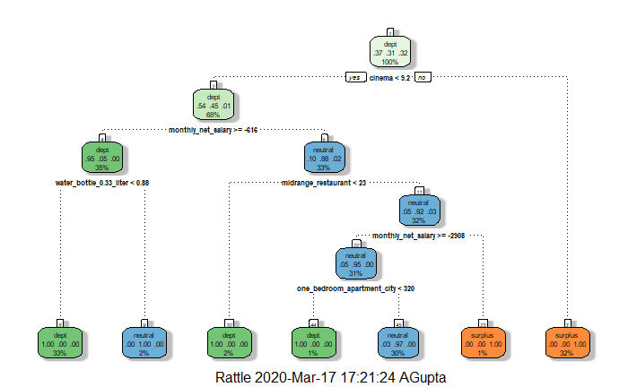

**Tree 2 –**

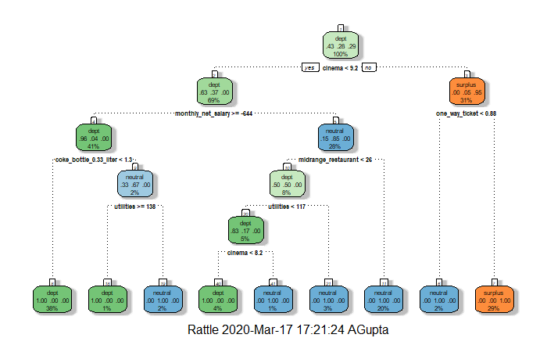

**Tree 3 –**

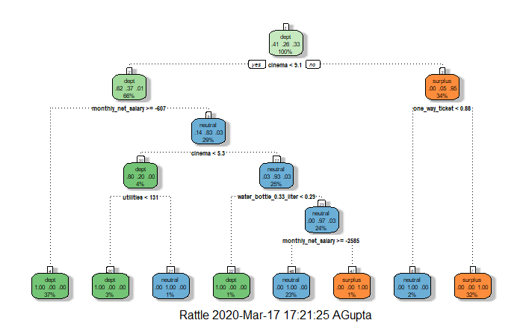

**Tree 4 –**

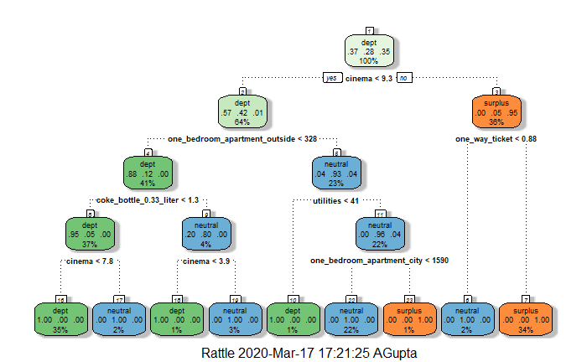

**Confusion Matrix**

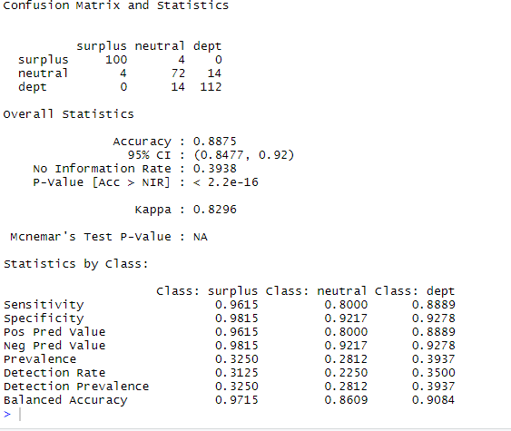

Overall, as can be seen the decision tree algorithm is learning well and predicting quiet accurately. The Accuracy is almost 88%. The MaxDepth and MinSplit is 5 and 2 in this case.

**Naïve Bayes**

The Naïve Bayes classifier is a simple probabilistic classifier based on Bayes theorem but with strong assumptions regarding independence. Historically, this technique became popular with applications in email filtering, document categorization and spam detection.

Bayesian probability incorporates the concept of conditional probability, the probability of event A given that event B has occurred [denoted as P(A|B)P(A|B)]. A key parameter in Naïve Bayes is the Laplace parameter. Laplace smoothing is nothing but replacing zero conditioning probability with some minimum value and when laplace = 0, laplace smoothing is disabled

**Output of Naïve Bayes**

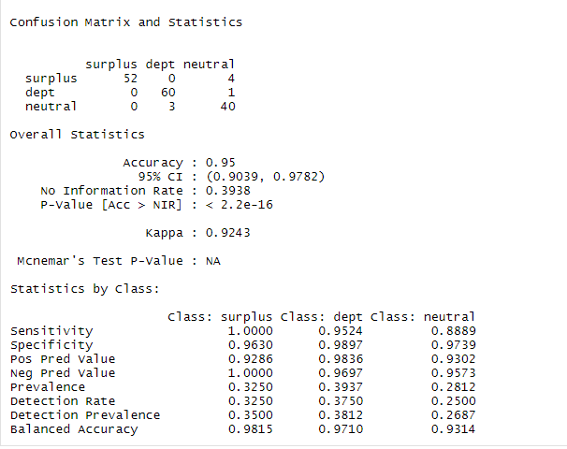

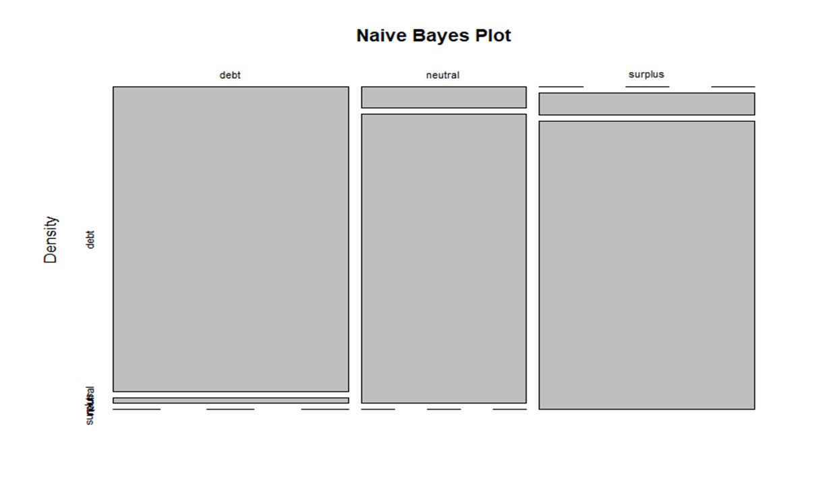

As can be seen the output of the default algorithm is 95%. The confusion matrix clearly indicates that the prediction of different clustering such as Surplus, Neutral and Debt is extremely close to being accurate.

**SVM**

The goal of an SVM is to take groups of observations and construct boundaries to predict which group future observations would belong to, based on their measurements. The different groups which are separated are called “classes”. SVMs can handle any number of classes, as well as observations of any dimension. SVMs can take almost any shape such as linear, radial, polynomial etc., and are generally flexible enough to be used in almost any classification endeavor that the user chooses to undertake.

**Different Variables and their importance while making SVM**

**1] Kernel –** The function of kernel is to take data as input and then transform it into the required form. Different SVM algorithms use different types of kernel functions.

Types of Kernels are as follows: Linear, Non-linear, Polynomial, Radial basis, and Sigmoid. For our analysis, we used Polynomial, Radial basis and Sigmoid functions.

**2] Cost –**

Cost function controls training errors and margins. For example, a **small cost** creates a large margin (a soft margin) and **allows more misclassifications**. On the other hand, a **large cost** creates a narrow margin (a hard margin) and **permits fewer misclassifications**. The negative side of introducing too large of a cost is the potential for overfitting the data and have the model predict badly against new data.

**Output of SVM**

**[1] Default kernel**

**1.1 Cost = 0.25**

As can be seen***, in Figure j***, the neutral cities have been predicted with utmost accuracy. The debt and surplus cities had some issues. In Debt 19 were predicted as being neutral and in surplus 11 were predicted as neutral. But overall the accuracy is 81 % which is good.

**Figure j: SVM 1**

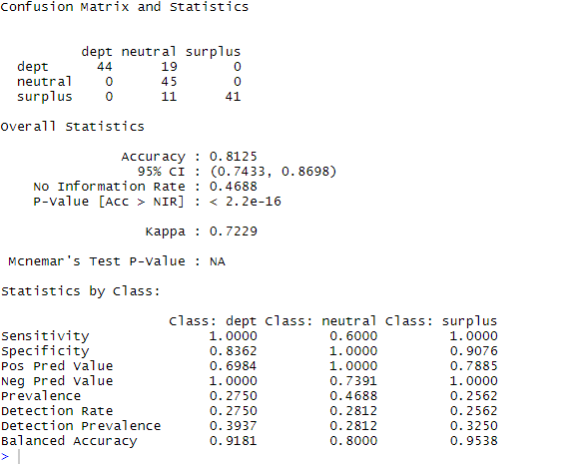

**1.2 Cost = 1**

As you see in Figure k, 1 debt city has been classified as neutral. 5 neutral cities have been classified as debt and 2 have been classified as surplus. The over all prediction is 95% accurate.

**Figure k: SVM 2**

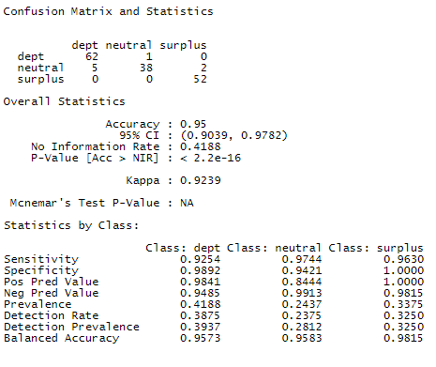

**Analysis –**

* 1. **Cost = 2**

As you can see, ***in Figure I below,*** 2 debt cities has been classified as neutral. 5 neutral cities have been classified as debt. 1 Surplus city has been predicted as neutral. The overall prediction is 95% accurate.

**Figure l: SVM 3**

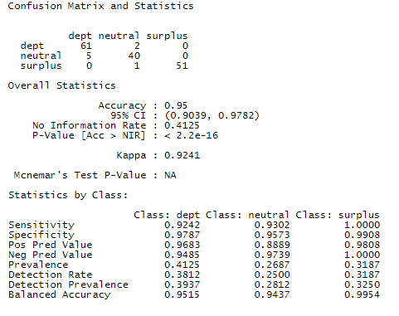

**[2] Polynomial kernel**

**2.1 Cost = 0.25**

As can be seen***, in Figure m below***, the neutral cities have been predicted with utmost accuracy. The debt and surplus cities had some issues. In Debt 19 were predicted as being neutral and in surplus 11 were predicted as neutral. But overall the accuracy is 81% which is good.

**Figure m: SVM 4**

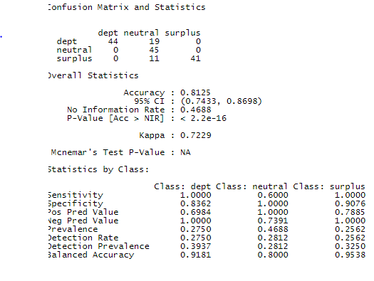

**Cost = 1**

As can be seen, ***in Figure n,*** the neutral cities have been predicted with utmost accuracy. The debt and surplus cities had some issues. In Debt 8 were predicted as being neutral and in surplus 4 were predicted as neutral. But overall the accuracy is 92.5%.

**Figure n: SVM 5**

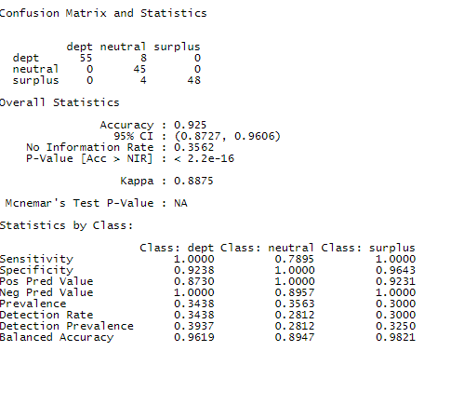

* 1. **Cost = 2**

As can be seen, ***in Figure o,*** the neutral cities have been predicted with utmost accuracy. The debt and surplus cities had some issues. In debt 4 were predicted as being neutral and in surplus 5 were predicted as neutral. But overall the accuracy is 94.3%.

**Figure o: SVM 6**

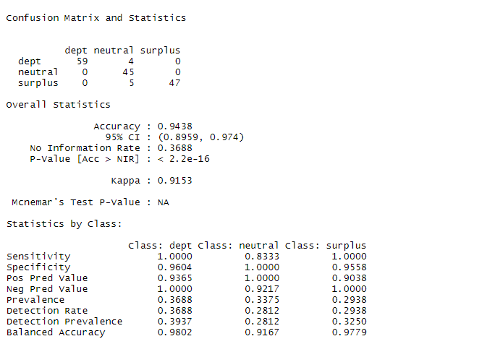

**[3] Sigmoid kernel**

**3.1 Cost = 0.25**

As can be seen, ***in Figure p***, the debt and surplus cities have been predicted with utmost accuracy. The neutral cities had some issues. In neutral 7 were predicted as being debt and 4 were predicted as surplus. But overall the accuracy is 93.1%.

**Figure p: SVM 7**

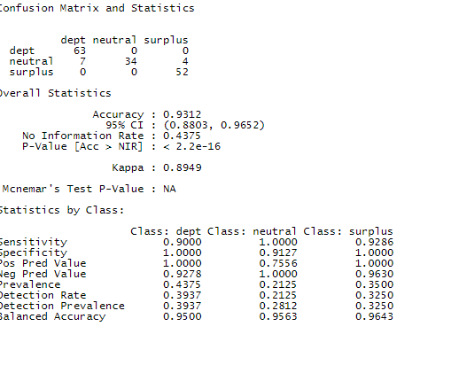

**3.1 Cost = 1**

As can be seen, ***in Figure q***, the debt cities have been predicted with utmost accuracy. The neutral and surplus cities had some issues. In neutral 5 were predicted as being debt and 4 being surplus. In surplus 1 city was predicted as neutral. But overall the accuracy is 93.7 %.

**Figure q: SVM 8**

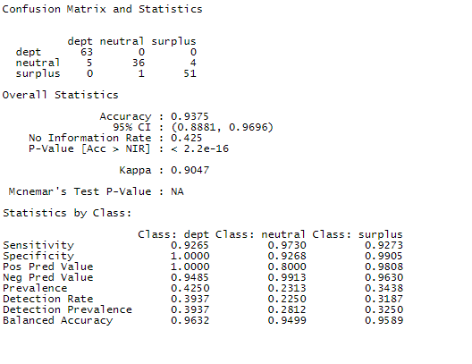

* 1. **Cost = 2**

In this analysis, *Figure r below*, 1 debt city was classified as neutral, 8 neutral cities were misclassified, and 1 surplus city was misclassified. Overall accuracy is 93.75%.

**Figure r: SVM 9**

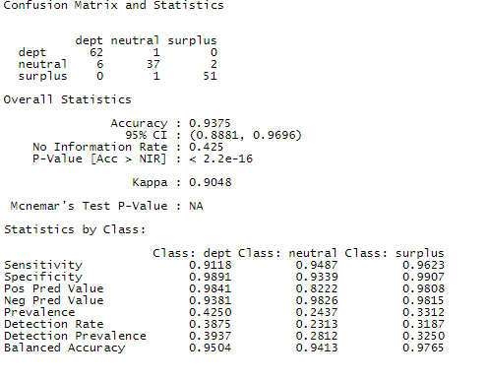

Overall, the model that performed the best was SVM, with our preprocessed baseline, and a cost of 2. See ***Figure S,*** with a complete list of resulting accuracy of the models.

Figure s: Model Outputs (Consolidated)

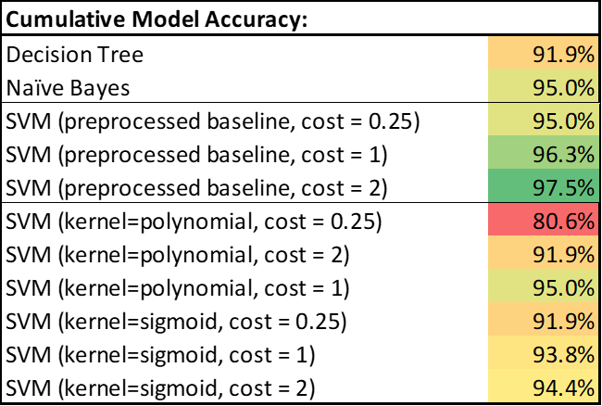

**Conclusion –**

This particular project started with trying to find a few answers for our groupmate but it was soon realized that it would have much bigger implications. There was a lot of data collected in different sources but certainly no source for information. As we all know from the knowledge triangle for the data to be turned into knowledge it requires effective analysis utilizing data analysis tools.

After going through different methods of data analysis such as clustering we found that most of the cities in surplus category were cities spread over different countries in Europe and quite a few were in the United States. Cities in the debt category belonged to countries in Asia, Africa and Middle East and this was in tune with the economic zones. It is common knowledge that countries in Asia and Africa are mostly all developing nations and hence it is understandable to find cities which have low income as compared to the high cost of living in these countries. While Middle East is usually rich, there are few cities in Egypt, Kazakhstan etc. which are still developing. Most of the cities in Neutral Cluster belonged in Europe, South Korea and Canada. So, depending on a person’s comfort they can choose to be in any cluster.

It was discovered that the major variables contributing to the cost of living were utilities, transportation, housing, mortgage interest rate, monthly income and essentials such as food and drinks. Understanding the relationship between seemingly independent variables will help them track the unthought of variables for example mortgage rate influencing food rate. All this information is certainly going to make it easier for the nomads of this world to decide their next destination without investing too much time and energy.

Our hypothesis was that we could simplify how we evaluate cost of living (COL) across different cities using a small subset of variables. We showed fairly high accuracy (with SVM performing the best ***– see Figure S***) in our predictions utilizing income and cost to borrow. Most other cost variables followed nicely with cost to borrow. We also noted that transportation and housing variables showed positive correlation in our modeling, as such we could expand our analysis in the future to include those 4 variables.

It would have been good to have consistent data (e.g. unit of measure), categorical data (Food, Housing, etc.), outcome data (good/bad, etc.). Also, you don’t know what you don’t know!! The Kaggle data we chose was not the best and teams had not done much in terms of submissions (chose based on “usability score” without knowledge of applications). Having a data set with more categorical data and a result in place for each observation (survived in Titanic) would have made the analysis much simpler. Then again, we would have not learned as much as we have completing this project.